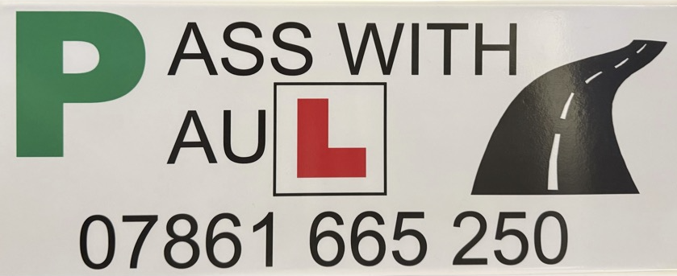 🚘 Driving Instructor Terms & Conditions
1. Lesson Bookings
- Lessons must be booked in advance and are subject to availability.
- Each lesson includes pick-up and drop-off at an agreed location.
- Lessons are available in 1.5-hour or 2-hour durations.

2. Payments
- Lesson fees are payable in advance.
- Accepted payment methods: cash, bank transfer, or online payment (if applicable).

3. Cancellations & Refunds
- A minimum of 48 hours’ notice is required to cancel or reschedule a lesson.
- Cancellations made with less than 48 hours’ notice will be charged in full.
- No refunds will be issued for missed lessons without notice.
- In the case of instructor cancellations (e.g., illness, emergency), the lesson will be rescheduled at no extra cost.

4. Punctuality
- Students are expected to be ready at the agreed time and location.
- Instructors will wait up to 15 minutes. After that, the lesson may be cancelled and charged as a late cancellation.

5. Learner Requirements
- Learners must hold a valid UK provisional driving licence.
- Learners must inform the instructor of any medical conditions or medication that may affect driving.
- It is the learner’s responsibility to ensure they bring glasses/contact lenses if needed to meet eyesight requirements.

6. Practical Test
- The instructor will advise when the learner is ready to take the driving test.
- Use of the instructor’s car for the driving test is at their discretion.
- A fee may apply for use of the instructor’s vehicle on test day.

7. Conduct
- Abusive, aggressive, or inappropriate behaviour will not be tolerated and may result in termination of lessons without refund.
- The instructor reserves the right to terminate a lesson if they feel the learner is unfit to drive (e.g. under the influence of alcohol or drugs).

8. Insurance
- The instructor’s vehicle is fully insured for learner drivers.
- Learners will not be held liable for damage to the vehicle unless caused by reckless or intentional behaviour.

By booking a lesson, you agree to these terms and conditions. These terms may be updated from time to time.

